**Use Case Diagram**

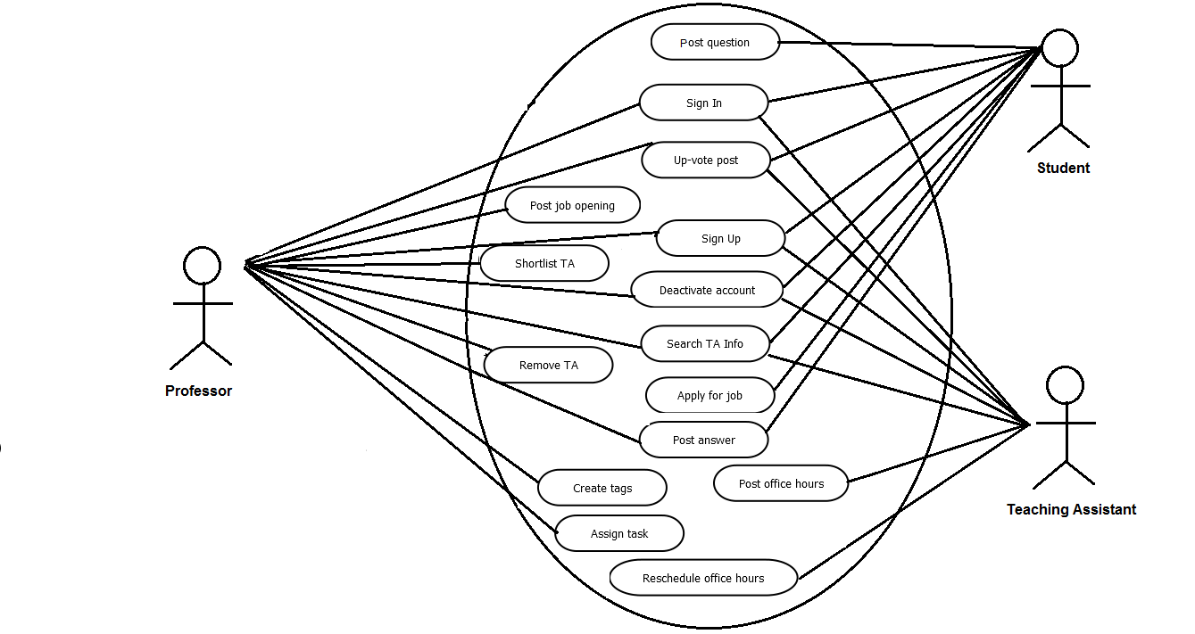

**Use Case Description**

1. **Use Case:**  Student signs up for Portal.

**Actor:** Student.

**Preconditions:**

1. Portal exists

|  |  |
| --- | --- |
| **Actor Actions** | **System Responses** |
| Student creates account for accessing application/Portal | Student is saved in the system |
|  |  |

1. **Use Case:**  User logs in to Portal when already assigned to a course.

**Actor:** Admin, Professor, TA and student.

**Preconditions:**

1. User account exists.

|  |  |
| --- | --- |
| **Actor Actions** | **System Responses** |
| 1. User signs in to the system | 1. User is given access to the system. |
|  |  |

1. **Use Case:**  Student logs in to the system when he/she is not assigned to any course.

**Actor:** Student.

**Preconditions:**

1. User exists.

|  |  |
| --- | --- |
| **Actor Actions** | **System Responses** |
| Student tries to log in to the system. | System does not allow user to login to the portal and redirects to an error page. |
|  |  |

1. **Use Case:**  Admin creates accounts for professors.

**Actor:** Admin.

**Preconditions:**

1. Admin should be logged in.

|  |  |
| --- | --- |
| **Actor Actions** | **System Responses** |
| Admin creates profile for new professor. | New professor’s information is saved in the system. |
|  |  |

1. **Use Case:**  Admin deletes professor details.

**Actor:** Admin.

**Preconditions:**

1. Admin should be logged in.
2. Professor should exist in the system.

|  |  |
| --- | --- |
| **Actor Actions** | **System Responses** |
| Admin deletes existing professor. | Professor is deleted from the system. |
|  |  |

1. **Use Case:**  Admin edits professor details.

**Actor:** Admin.

**Preconditions:**

1. Admin should be logged in.
2. Professor should exist in the system.

|  |  |
| --- | --- |
| **Actor Actions** | **System Responses** |
| Admin enters updated information for the existing professor. | Professor details are updated in the system |
|  |  |

1. **Use Case:**  Admin assigns courses to professors.

**Actor:** Admin.

**Preconditions:**

1. Admin should be logged in.
2. Courses and Professor exist in the system.

|  |  |
| --- | --- |
| **Actor Actions** | **System Responses** |
| Admin selects courses for professor. | Selected courses are assigned to the professor. |
|  |  |

1. **Use Case:**  Admin adds courses.

**Actor:** Admin.

**Preconditions:**

1. Admin should be logged in.

|  |  |
| --- | --- |
| **Actor Actions** | **System Responses** |
| Admin enters details for new course. | A new course is created. |
|  |  |

1. **Use Case:**  Admin edits course details.

**Actor:** Admin.

**Preconditions:**

1. Admin should be logged in.
2. Courses should exist in the system.

|  |  |
| --- | --- |
| **Actor Actions** | **System Responses** |
| Admin enters updated information for the existing course. | Course details are updated in the system |
|  |  |

1. **Use Case:**  Admin deletes course details.

**Actor:** Admin.

**Preconditions:**

1. Admin should be logged in.
2. Courses should exist in the system.

|  |  |
| --- | --- |
| **Actor Actions** | **System Responses** |
| Admin deletes existing courses. | Course is deleted from the system. |
|  |  |

1. **Use Case:**  Admin assigns courses to students.

**Actor:** Admin.

**Preconditions:**

1. Admin should be logged in.
2. Courses should exist in the system.
3. Student should exist.

|  |  |
| --- | --- |
| **Actor Actions** | **System Responses** |
| Admin maps courses to the students, | Student is assigned to the selected courses |
|  |  |

1. **Use Case:** TA declares his office hours

**Actor:** TA

**Preconditions:**

1. TA is already assigned to a course.

|  |  |
| --- | --- |
| **Actor Actions** | **System Responses** |
| TA posts office hours | 1. System saves TA office hours. |
|  |  |

1. **Use Case:** TA edits his office hours

**Actor:** TA

**Preconditions:**

1. TA is already assigned to a course.
2. TA schedule exists

|  |  |
| --- | --- |
| **Actor Actions** | **System Responses** |
| TA updates his schedule/location | TA schedule is updated in the system |
|  |  |

1. **Use Case:** TA deletes his office hours

**Actor:** TA

**Preconditions:**

1. TA is already assigned to a course.
2. TA schedule exists

|  |  |
| --- | --- |
| **Actor Actions** | **System Responses** |
| TA deletes his schedule/location | TA schedule is deleted in the system |
|  |  |

1. **Use Case:** Professor selects TA from the list of students.

**Actor:** Professor

**Preconditions:**

1. Students are available
2. Professor is logged in.

|  |  |
| --- | --- |
| **Actor Actions** | **System Responses** |
| Professor selects TA from the list of applicants. | System assigns TA to a course. |
|  |  |

1. **Use Case:** Professor posts TA job openings.

**Actor:** Professor

**Preconditions:**

1. Professor is assigned to a course.
2. Professor is logged in.

|  |  |
| --- | --- |
| **Actor Actions** | **System Responses** |
| Professor uploads openings for TA. | Job opening is uploaded. |
|  |  |

1. **Use Case:** Professor views job applicant’s Job-application.

**Actor:** Professor

**Preconditions:**

1. Professor is assigned to a course.
2. Professor is logged in.
3. Student, TA must exist.
4. Student and TA must have submitted job application.

|  |  |
| --- | --- |
| **Actor Actions** | **System Responses** |
| Professor views applicant’s information | Job opening is seen by the professor. |
|  |  |

1. **Use Case:** Student and TA view job openings for courses which are assigned to them.

**Actor:** Student and TA.

**Preconditions:**

1. Student, TA is logged in.
2. Student, TA assigned to a course.
3. Job opening is already posted by the professor.

|  |  |
| --- | --- |
| **Actor Actions** | **System Responses** |
| Student and TA views job. | System displays all the jobs posted by a professor for the courses which are assigned to the logged in users. |
|  |  |

1. **Use Case:** Student and TA apply for job.

**Actor:** Student and TA

**Preconditions:**

* 1. Job opening for actors is available on Portal.
  2. Actors exist and should be logged in.

|  |  |
| --- | --- |
| **Actor Actions** | **System Responses** |
| Student submits his application | 1. System stores Student’s profile 2. Applicant information is sent to the Professor. |
|  |  |

1. **Use Case:** User creates a new thread for asking question.

**Actor:** Professor, Student and TA

**Preconditions:**

* 1. User is logged in to the system.
  2. A course is already assigned to a user.

|  |  |
| --- | --- |
| **Actor Actions** | **System Responses** |
| User submits a new thread for any assigned course. | A new thread is saved in the system. |
|  |  |

1. **Use Case:** User views a thread.

**Actor:** Professor, Student and TA

**Preconditions:**

* 1. User is logged in to the system.
  2. A course is already assigned to a user.
  3. A thread already exists.

|  |  |
| --- | --- |
| **Actor Actions** | **System Responses** |
| User can view an existing thread. | System renders a thread for the logged in user. |
|  |  |

1. **Use Case:** User marks a new thread as favorite.

**Actor:** Professor, Student and TA

**Preconditions:**

* 1. User is logged in to the system.
  2. Thread exists.
  3. A course is already assigned to a user.

|  |  |
| --- | --- |
| **Actor Actions** | **System Responses** |
| User sets any thread as favorite. | A thread is marked as a favorite for a user in the system |
|  |  |

1. **Use Case:** User un-favorites a thread.

**Actor:** Professor, Student and TA

**Preconditions:**

* 1. User is logged in to the system.
  2. Favorite thread exists.
  3. A course is already assigned to a user.

|  |  |
| --- | --- |
| **Actor Actions** | **System Responses** |
| User marks a thread as un-favorite. | A thread is no more marked as a favorite for a user in the system |
|  |  |

1. **Use Case:** User creates a tag.

**Actor:** Professor and TA

**Preconditions:**

* 1. Actor is logged in to the system.
  2. A course is already assigned to a user.

|  |  |
| --- | --- |
| **Actor Actions** | **System Responses** |
| User creates a new tag. | A tag is created in the system so that user can select from it while posting a thread. |
|  |  |

1. **Use Case:** User assigns a tag to a thread while posting it.

**Actor:** Professor, Student and TA

**Preconditions:**

* 1. User is logged in to the system.
  2. A course is already assigned to a user.

|  |  |
| --- | --- |
| **Actor Actions** | **System Responses** |
| User associates tag/tags to a thread. | A tag is assigned to a newly created thread in the system. |
|  |  |

1. **Use Case:** User searches for a thread using a keyword.

**Actor:** Professor, Student and TA

**Preconditions:**

* 1. User is logged in to the system.
  2. A course is already assigned to a user.
  3. A thread exists in the system.

|  |  |
| --- | --- |
| **Actor Actions** | **System Responses** |
| User looks for existing thread providing keyword. | System renders all threads containing given keyword in thread’s title or content. |
|  |  |

1. **Use Case:** User posts replies to a thread.

**Actor:** Professor, Student and TA

**Preconditions:**

* 1. User is logged in to the system.
  2. A course is already assigned to a user.
  3. A thread exists in the system.

|  |  |
| --- | --- |
| **Actor Actions** | **System Responses** |
| User adds a new post for an existing thread. | A post is saved in the system for the selected thread. |
|  |  |

1. **Use Case:** User likes a post.

**Actor:** Professor, Student and TA

**Preconditions:**

* 1. User is logged in to the system.
  2. A course is already assigned to a user.
  3. A post exists for a thread in the system.

|  |  |
| --- | --- |
| **Actor Actions** | **System Responses** |
| User like a post. | A post is marked as liked post for the user. |
|  |  |

1. **Use Case:** User un-likes a post.

**Actor:** Professor, Student and TA

**Preconditions:**

* 1. User is logged in to the system.
  2. A course is already assigned to a user.
  3. A liked post exists for a thread in the system.

|  |  |
| --- | --- |
| **Actor Actions** | **System Responses** |
| User unlike a post. | A post is marked as un-liked post for the user. |
|  |  |

1. **Use Case:** User views posts.

**Actor:** Professor, Student and TA

**Preconditions:**

* 1. User is logged in to the system.
  2. A course is already assigned to a user.
  3. A post exists for a thread in the system.

|  |  |
| --- | --- |
| **Actor Actions** | **System Responses** |
| User can view all posts which exist for a thread. | System renders posts for a thread. |
|  |  |

1. **Use Case:** User (Professor, students or TA) views TA information.

**Actor:** TA, Student and Professor.

**Preconditions:**

1. TA is already assigned to a course.

|  |  |
| --- | --- |
| **Actor Actions** | **System Responses** |
| 1. User views TA information. | 1. TA details displayed. |
|  |  |

1. **Use Case:** User logs out from his account.

**Actor:** Admin, Professor, TA and Student.

**Preconditions:**

1. User must be logged in to the system.

|  |  |
| --- | --- |
| **Actor Actions** | **System Responses** |
| Users are taken to the log in page. | A logged in user in logged out of the system. |
|  |  |

1. **Use Case:** User views profile of other users who are present in his assigned courses.

**Actor:** Professor, TA and Student.

**Preconditions:**

1. User must be logged in to the system.
2. Other users must exist in the course to which a user is assigned.

|  |  |
| --- | --- |
| **Actor Actions** | **System Responses** |
| A user can browse his classmates, TAs and professor’s profiles. | System allows a logged in user to view profile of other users. |
|  |  |

1. **Use Case:** User follows TAs, students and professor of his assigned courses.

**Actor:** Professor, TA and Student.

**Preconditions:**

1. User must be logged in to the system.
2. Other users must exist in the course to which a user is assigned.

|  |  |
| --- | --- |
| **Actor Actions** | **System Responses** |
| User adds TAs, students and professor of his assigned courses to his ‘following’ list. | System adds user in the ‘following’ list of the logged in user. |
|  |  |

1. **Use Case:** User un-follows TAs, students and professor of his assigned courses from his ‘following’ users list.

**Actor:** Professor, TA and Student.

**Preconditions:**

1. User must be logged in to the system.
2. Other users must exist in the course to which a user is assigned.
3. Other users must exist in the ‘following’ list of the logged in user.

|  |  |
| --- | --- |
| **Actor Actions** | **System Responses** |
| User removes TAs, students and professor of his assigned courses to his ‘following’ list. | System removes user in the ‘following’ list of the logged in user. |
|  |  |

1. **Use Case:** User views his ‘following’ and ‘follower’ users list on the profile page.

**Actor:** Professor, TA and Student.

**Preconditions:**

1. User must be logged in to the system.
2. Other users must exist in the course to which a user is assigned.
3. Other users must exist in the ‘following’ and ‘follower’ list of the logged in user.

|  |  |
| --- | --- |
| **Actor Actions** | **System Responses** |
| User views his ‘following’ and ‘follower’ users list on the profile page. | System displays the list of ‘following’ and ‘followed’ list of the logged in user. |
|  |  |

1. **Use Case:** User deletes account.

**Actor:** Professor, TA and Student.

**Preconditions:**

1. User account exist.

|  |  |
| --- | --- |
| **Actor Actions** | **System Responses** |
| 1. Professor and TA create tags. | 1. Tag is saved in the system. |
|  |  |